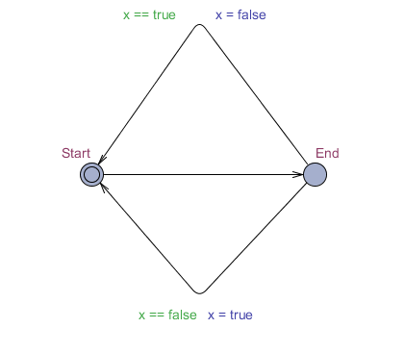

From the initial state we conclude that the initial value of x from Start terminal hold the value= false and go to end terminal with the value of x=false. There are 2 path with different condition and guard. For the top path the guards is x==true, and the below path x==false. Now the value of x is equal to false then the x will go to path that guard is x==false. After x reach the start terminal the value of x will update to x=true. Now the value of x is true. The process will run and follow the guard condition.

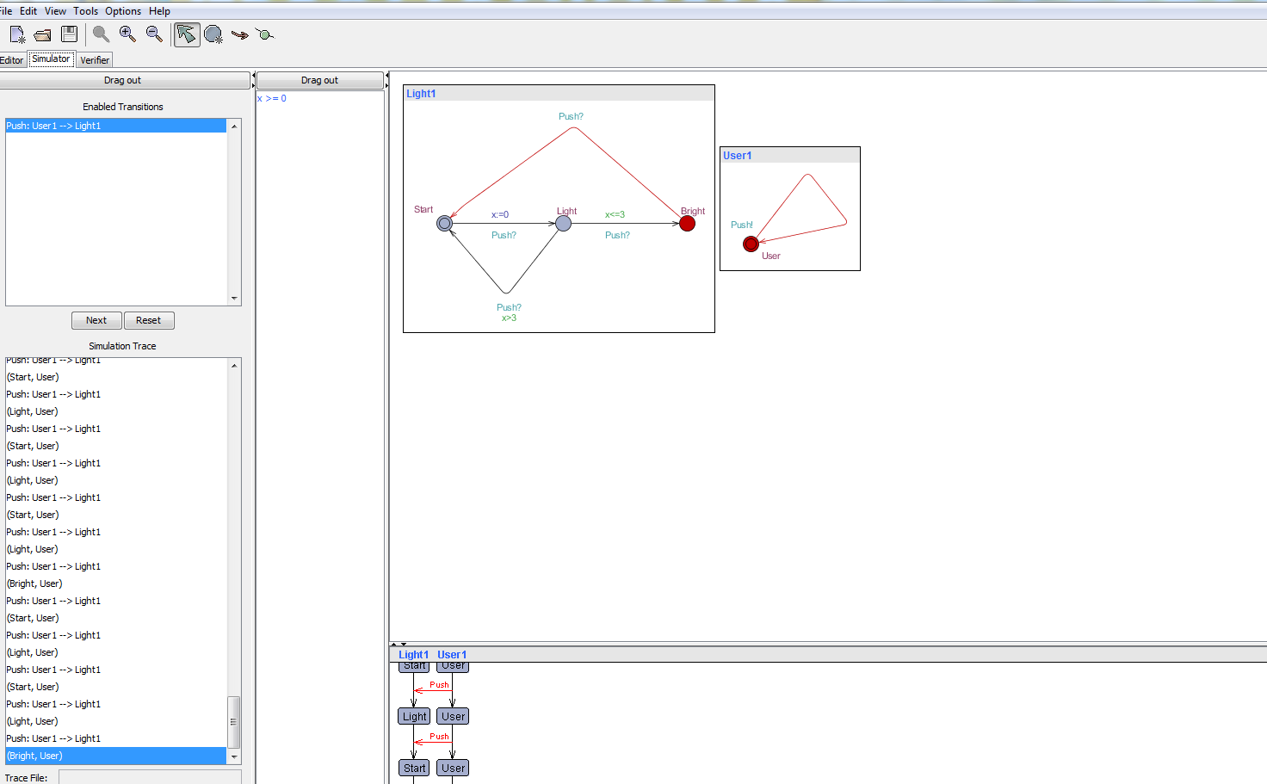

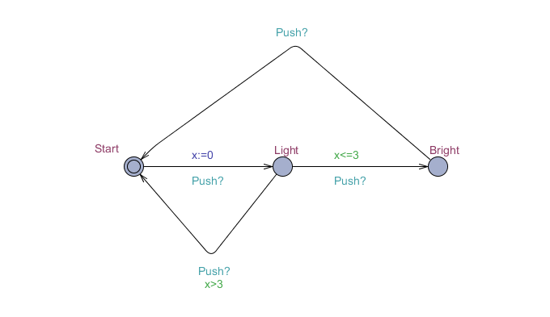

From this intelligent light control there have several condition with this light control. For example is user presses the light control then it lights, more over if a user quickly presses the light control then the light should get brighter and lastly if the user slowly presses the light control the light should turn off. Synchronization (Push?) means that two processes make transition or change location in one step. Synchronization is done via channels. To synchronize two processes, the edges should be labeled with the channel variable that has been declared (e.g. Chan Push) followed by ‘!’ For one of the m and ‘?’ for the other.

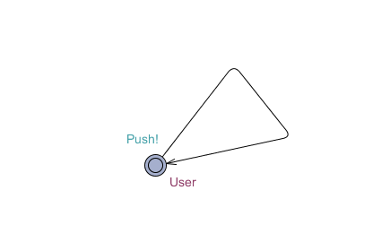

This synchronization is depends on the figure above. When the user push the button. The light template will run and detect how many User push the button. The initial value of x is 0 when the user push for the first time and the light will appear .If the user push more than 3 times the light will shut down. If the user push the button twice the light will go to brighter (bright terminal).If the user push again the button the light will shut down.